Chapter 18, Solution 31.

(a) 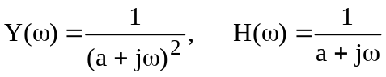

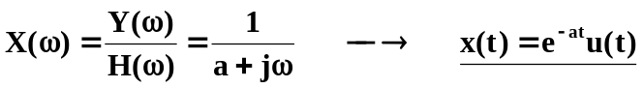

(b) By definition, 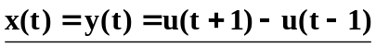

(c ) 